Nama : Ahmad Naufal Ramadhan

NIM : 103012300239

Kelas : IF-47-02

1. 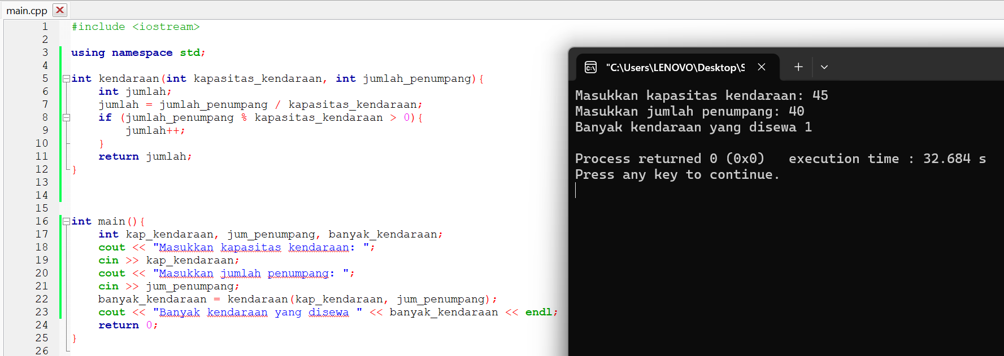

1. A screen shot of a computer

   Description automatically generated
2. A screenshot of a computer program

   Description automatically generated